**Curriculum Vitae**

**Faculty of Electrical & Electronics Engineering**

**University Malaysia Pahang (UMP)**

Name : Tham Yi Wern

I/C No. : 940311-14-5224

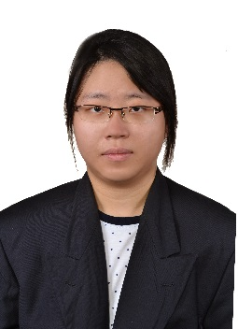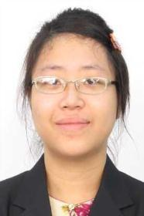Student ID : EC14058

Program : B.ENG (Hons) Electrical Engineering (Power System)

Address : 15, Jalan Perdana 2/18,

Pandan Perdana,

55300 Kuala Lumpur,

Malaysia.

Gender : Female

Age : 23 years old

Nationality : Malaysian

Email : thamyiwern_94@hotmail.com

No. Telephone : 016-3566115

**EDUCATION AND QUALIFICATIONS**

**EDUCATION**

Year 2015 - Current : University Malaysia Pahang Degree: CGPA 3.91

Year 2012 - 2015 : University Malaysia Pahang Diploma: CGPA 3.90

Year 2010 - 2011 : SMK Aminuddin Baki SPM: 3A+, 5A, 1A-

**QUALIFICATIONS**

Year 2012 : Dean List Award, Diploma 1st semester, 2012/2013

: Organizer of Expoconvo UMP’12

Year 2013 : Dean List Award, Diploma 2nd semester, 2012/2013

: Participate in Line Follower Robot Competition 2013

: Runner-up for Canoe Competition, category mixed, double

Year 2014 : Dean List Award, Diploma 3rd semester, 2013/2014

Year 2015 : UMP Colour Run, September

: Anugerah Hadiah Buku, October

: Champion for Happy Pekan Day, November

Year 2016 : Student exchange to Yogyakarta, Indonesia

**WORKING EXPERIENCE**

Eclimo Sdn. Bhd. June 2016 to August 2016

Position: Structural Internship

Job Description: supported in production of electric vehicle and Eclimo Power and participated in on-site service

Avialite Sdn. Bhd. August 2014 to January 2015

Position: Diploma Industrial Attachment

Job Description: supported in production of control panel and aviation obstruction light and responsible for troubleshoot in circuit cards

**CAREER OBJECTIVES**

‘*No one saves us but ourselves. No one can and no one may. We ourselves must walk the path.’ – Buddha.*

To gain a challenging role in the area of electrical engineering that have the best opportunity to further develop my knowledge and research for my final year project.

**SKILLS AND ABILITIES**

* Understanding the fundamentals of microcontroller, microprocessor, low voltage installation, maintenance technology, occupational safety & health and electrical power system.
* Hands-on skills such as electrical wiring.

**ADDITIONAL INFORMATION**

Language : English, Malay and Mandarin

Computing : AutoCAD, MATLAB, PLC, Arduino and Proteus

Leisure : Surfing the internet, jogging

Course taken : (please refer attachment)

**REFERENCE**

**Academic Advisor**

Dr. Mohd Razali bin Daud

Senior Lecturer (Academic Advisor),

Faculty of Electrical & Electronics Engineering,

University Malaysia Pahang.

HP: 0111-0776526

Email: mrazali@ump.edu.my